**PROJECT REPORT**

**BUSIFY:**

**A COMPREHENSIVE BUS SCHEDULE MANAGEMENT**

**& BOOKING SYSTEM**

**By**

**Linkan Kumar Rout**

**ID - MST01-0055**

ABSTRACT

This project report presents the development and implementation of "Busify," a comprehensive bus schedule management and booking system built using the Django framework. This project aims to streamline the management and booking of bus schedules through a user-friendly web application. The primary purpose is to provide an efficient platform for users to view, search, and book bus trips while enabling administrators to manage schedules easily. Technologies used include the Django framework for the backend and SQLite for the database, complemented by HTML, CSS, Bootstrap, and JavaScript for the frontend. The project incorporates secure user authentication and authorization, an admin interface for CRUD operations on bus schedules, and search and filter functionalities for users to find specific schedules. Additionally, it features efficient pagination and dynamic sorting of schedules to enhance user experience. An integral part of the system is the integration of email functionality to send booking confirmations automatically, ensuring users are notified of their bookings promptly. PayPal payment integration has been made in this project to facilitate seamless and secure online transactions for booking bus trips. The application is designed to be responsive and compatible with various devices, providing a seamless user experience. The project successfully delivers a functional web application that allows users to search for and book bus trips easily while enabling efficient schedule management through an admin panel. Automated status updates for schedules based on date and time are implemented, along with successful user authentication and email booking confirmations. This project demonstrates the effectiveness of Django in building scalable web applications with robust backend and responsive frontend capabilities, serving as a foundation for future enhancements and customization.

Table of Contents

1. Introduction

2. Project Overview

3. Technologies Used

4. System Architecture

5. Implementation Details

6. Challenges Faced

7. Future Enhancements

8. Conclusion

9. References

1. Introduction

The rapid advancements in technology have revolutionized various aspects of daily life, including transportation. Efficient transportation management is essential for the smooth functioning of urban and rural areas alike. With the increasing reliance on public transportation, there is a growing need for systems that can effectively manage bus schedules and bookings. This project, "Busify: A Comprehensive Bus Schedule Management and Booking System," aims to address this need by providing a robust, user-friendly platform for managing bus operations.

Busify is designed to streamline the process of bus schedule management, allowing administrators to create, update, and delete schedules with ease. The system also provides users with the ability to search for bus schedules, book tickets, and receive email confirmations for their bookings. Built using the Django framework, Busify leverages modern web technologies to ensure a responsive and intuitive user experience.

The project utilizes SQLite as its database, ensuring a lightweight yet powerful data storage solution. Front-end technologies such as HTML, CSS, Bootstrap, and JavaScript are employed to create an appealing and functional interface. The integration of these technologies results in a comprehensive system that caters to the needs of both administrators and users.

This report delves into the various aspects of the project, including its purpose, system architecture, implementation details, and the challenges faced during development. Additionally, it outlines potential future enhancements that could further improve the system's functionality and user experience. Through this project, we aim to contribute to the efficient management of public transportation, enhancing the convenience and reliability of bus services for users.

2. Project Overview

The project "Busify: A Comprehensive Bus Schedule Management and Booking System" represents a modern solution tailored for efficient management and booking of bus schedules. It addresses the critical need for a user-friendly platform that benefits both administrators and passengers alike. With a focus on usability and accessibility, Busify allows administrators to seamlessly create, update, and delete bus schedules through an intuitive web interface. This ensures schedules are accurately maintained and readily accessible to users. Built using contemporary technologies such as Django, HTML, CSS, Bootstrap, and JavaScript, Busify offers a responsive and visually appealing interface. Users can effortlessly search for bus schedules based on their preferences and book tickets with minimal effort.

One of Busify's standout features is its streamlined booking and confirmation process. Users can securely book bus tickets directly through the platform and receive email confirmations, enhancing reliability and convenience. The project leverages SQLite as its database, ensuring efficient data management and system performance even under high load conditions. Looking forward, Busify is designed with scalability in mind, paving the way for future enhancements such as integration with additional payment gateways, real-time bus tracking functionalities, and advanced analytics for route optimization. This project report provides a comprehensive overview of the development journey, system architecture, implementation strategies, challenges faced, and opportunities for further enhancement.

3. Technologies Used

1. Django – 4.2.13

2. Python – 3.11.9

3. HTML 5

4. CSS 3

5. JavaScript

6. Bootstrap 4

7. J Query

8. G-mail (for smtp config)

9. SQLite3 (default database engine)

10. PayPal (Payment Gateway Integration)

4. System Architecture

Busify's system architecture is designed to provide a robust and scalable platform for managing bus schedules and bookings effectively. The architecture is structured into frontend, backend, database management, and integration with essential services.

The **frontend** of Busify is developed using HTML, CSS, JavaScript, and Bootstrap, ensuring a responsive and user-friendly interface. These technologies enable dynamic rendering of content, seamless navigation, and intuitive user interactions. The frontend communicates with the backend via HTTP requests to retrieve data, update schedules, and manage user bookings.

On the **backend**, Busify leverages Django, a powerful Python-based web framework. Django's MVC (Model-View-Controller) architecture and ORM (Object-Relational Mapping) simplify the development of complex business logic and ensure efficient data handling. The backend manages user authentication, business rules for scheduling, and data persistence using SQLite, a lightweight relational database. SQLite is chosen for its simplicity, compatibility with Django, and ability to handle moderate data volumes effectively.

Busify integrates SMTP for email notifications, keeping users informed about their booking statuses in real-time. The architecture is designed to support potential integrations with third-party APIs, such as payment gateways or location services, to enhance functionality and provide additional value to users.

In summary, Busify's system architecture is tailored to meet the demands of managing bus schedules and bookings efficiently. It ensures reliability, scalability, and maintainability, providing a seamless experience for both users booking bus tickets and administrators managing schedules.

5. Implementation Details

**Home Page:** The Home Page (/ or /home) serves as the gateway to the Busify platform, offering a welcoming introduction and overview of its services. It prominently features a carousel or banner section highlighting key features, promotional offers, or current bus routes. This page aims to engage users immediately upon arrival, encouraging them to explore further.

**Find Trip Page:** The Find Trip Page provides a user-friendly interface for users to search for specific bus trips based on various parameters. Users can input departure and destination locations, preferred date and time to refine their search. The page displays relevant schedules that meet the search criteria, facilitating efficient trip planning.

**All Schedules Page:** The All Schedules Page provides a comprehensive listing of all available bus schedules within the Busify system. It displays schedules in a structured table format, detailing essential information such as bus number, departure point, destination, schedule time, fare per person, and the current status (active or cancelled). Users can paginate through the schedules and utilize sorting options to find specific routes or times that suit their travel needs.

**Search Results Page:** Upon initiating a search query through the site's search functionality (typically accessed via a search bar on the navigation or schedules page), users are directed to the Search Results Page. This page dynamically generates results based on the user's search terms, displaying schedules that match the criteria. It enhances user convenience by quickly narrowing down available schedules based on specific preferences or destinations.

**Authentication Pages:** Authentication Pages are crucial for user security and access management. The Login Page allows existing users to securely sign in to their accounts, while the Registration Page enables new users to create profiles within the Busify system. These pages ensure that user interactions with the platform are authenticated and protected, enhancing overall security and trust.

**Bus Categories Page:** The Bus Categories Page showcases different categories of buses available for travel through Busify. It provides descriptions and features of each category, such as luxury, double decker, sleeper buses, mini bus etc. helping users choose the most suitable option for their journey preferences.

**Locations Page:** The Locations Page presents a comprehensive list of all available travel destinations serviced by Busify.

**Booking Confirmation Page:** The Booking Confirmation Page confirms the details of a successfully booked schedule. It displays essential booking information, including bus number, departure/destination locations, scheduled time, fare, and booking status. This page reassures users that their booking is confirmed but payment has to be done in user booking page and provides a reference for future travel plans.

**Contact Us Page:** The Contact Us Page offers users a direct means to communicate with Busify's support team. It includes a contact form where users can submit inquiries, feedback, or issues they encounter while using the platform. Additionally, contact details such as email addresses, phone numbers, and physical addresses may be provided for users preferring alternative communication methods.

**Payment Page:** The Payment Page facilitates secure online transactions for booking bus trips. Users can complete their payments through integrated payment gateways like PayPal. This page ensures a smooth and secure payment process, enabling users to finalize their bookings effortlessly.

**User Booking Page:** The User Booking Page displays all of a user's bookings, categorized by pending and completed bookings. For pending bookings, users have the option to make payments. For completed bookings, users can download their tickets and have the option to delete them if needed. This page provides users with a centralized location to manage their bus trip bookings effectively.

### 1. models.py

The models.py file is a crucial part of the Django project that defines the data models for the application. These models represent the structure of the database and include fields that describe the attributes of each model. In the Busify project, the models typically include:

* **Bus**: This model defines the attributes of a bus, such as the bus number, category, bus image and capacity.
* **Schedule**: This model contains information about bus schedules, including the bus, departure location, destination, time, fare, and status.
* **Category**: This model categorizes buses, such as luxury, inter-city, sleeper etc.
* **Location**: This model defines the travel destinations serviced by Busify.
* **Booking:** This model defines the booking made by user.

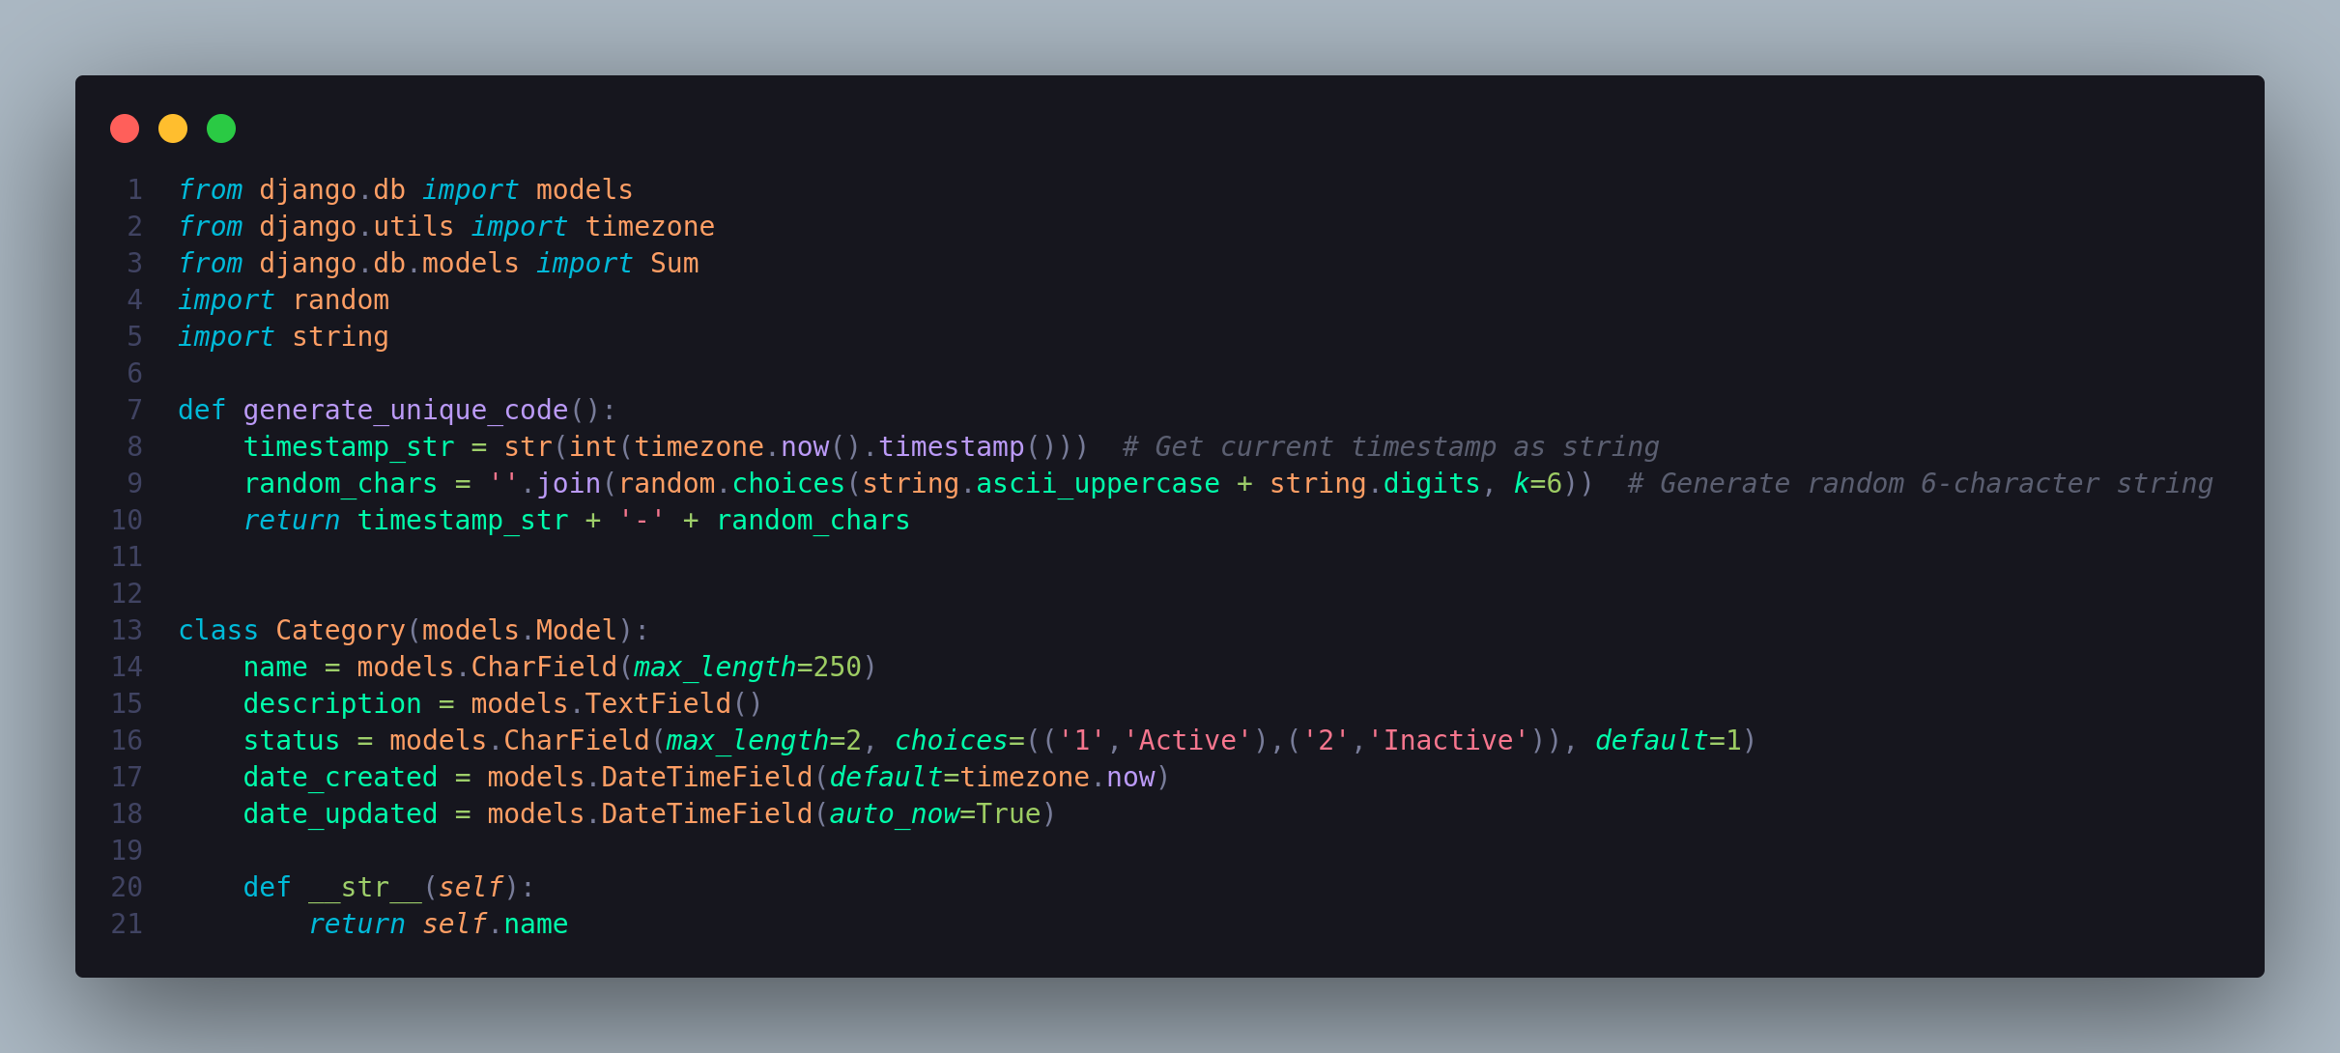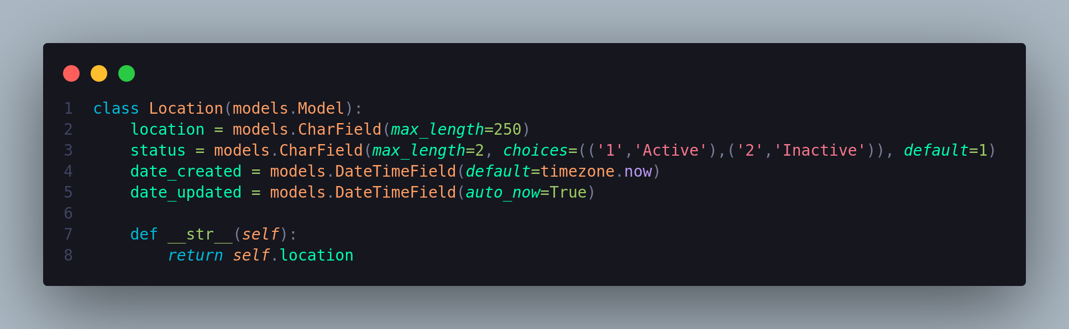

### 2. views.py

The views.py file is responsible for handling the logic of the application. It processes user requests, interacts with the models to retrieve or update data, and returns the appropriate responses, usually in the form of rendered HTML templates. Key views in the Busify project include:

* **Home Page View**: Renders the home page with introductory information and popular routes.
* **Schedule List View**: Displays all available bus schedules, allowing sorting and pagination.
* **Find Trip View**: Allows users to search for trips based on departure and destination locations and other criteria.
* **Bus Categories View**: Shows different categories of buses available.
* **Locations View**: Lists all available travel destinations.
* **Contact Us View**: Provides a form for users to submit inquiries or feedback.
* **Authentication Views**: Handles user login and registration processes.

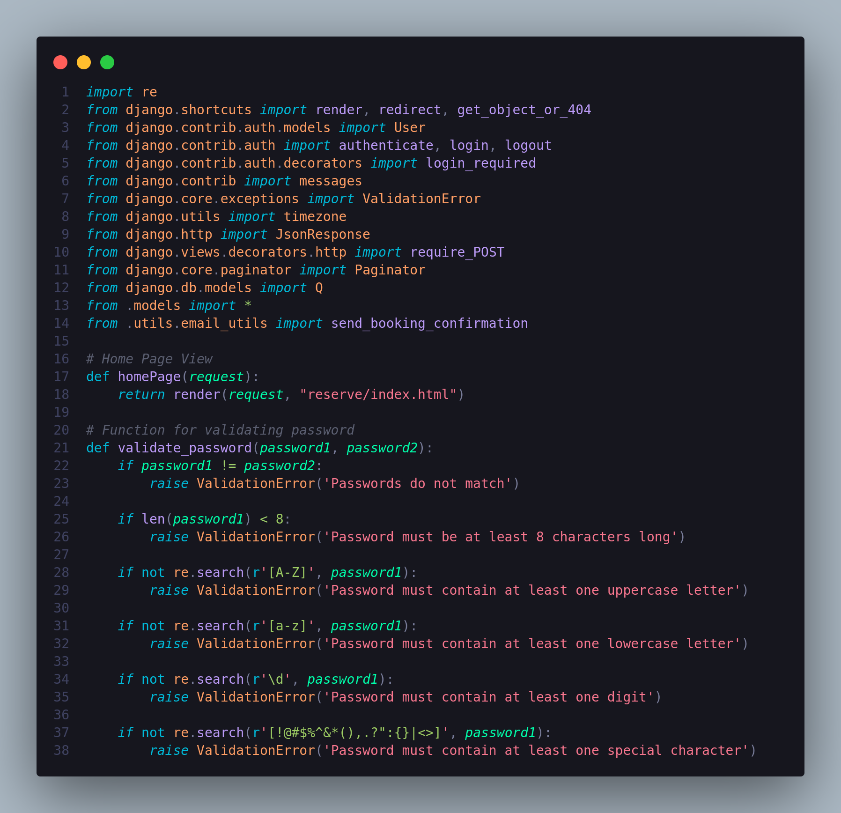

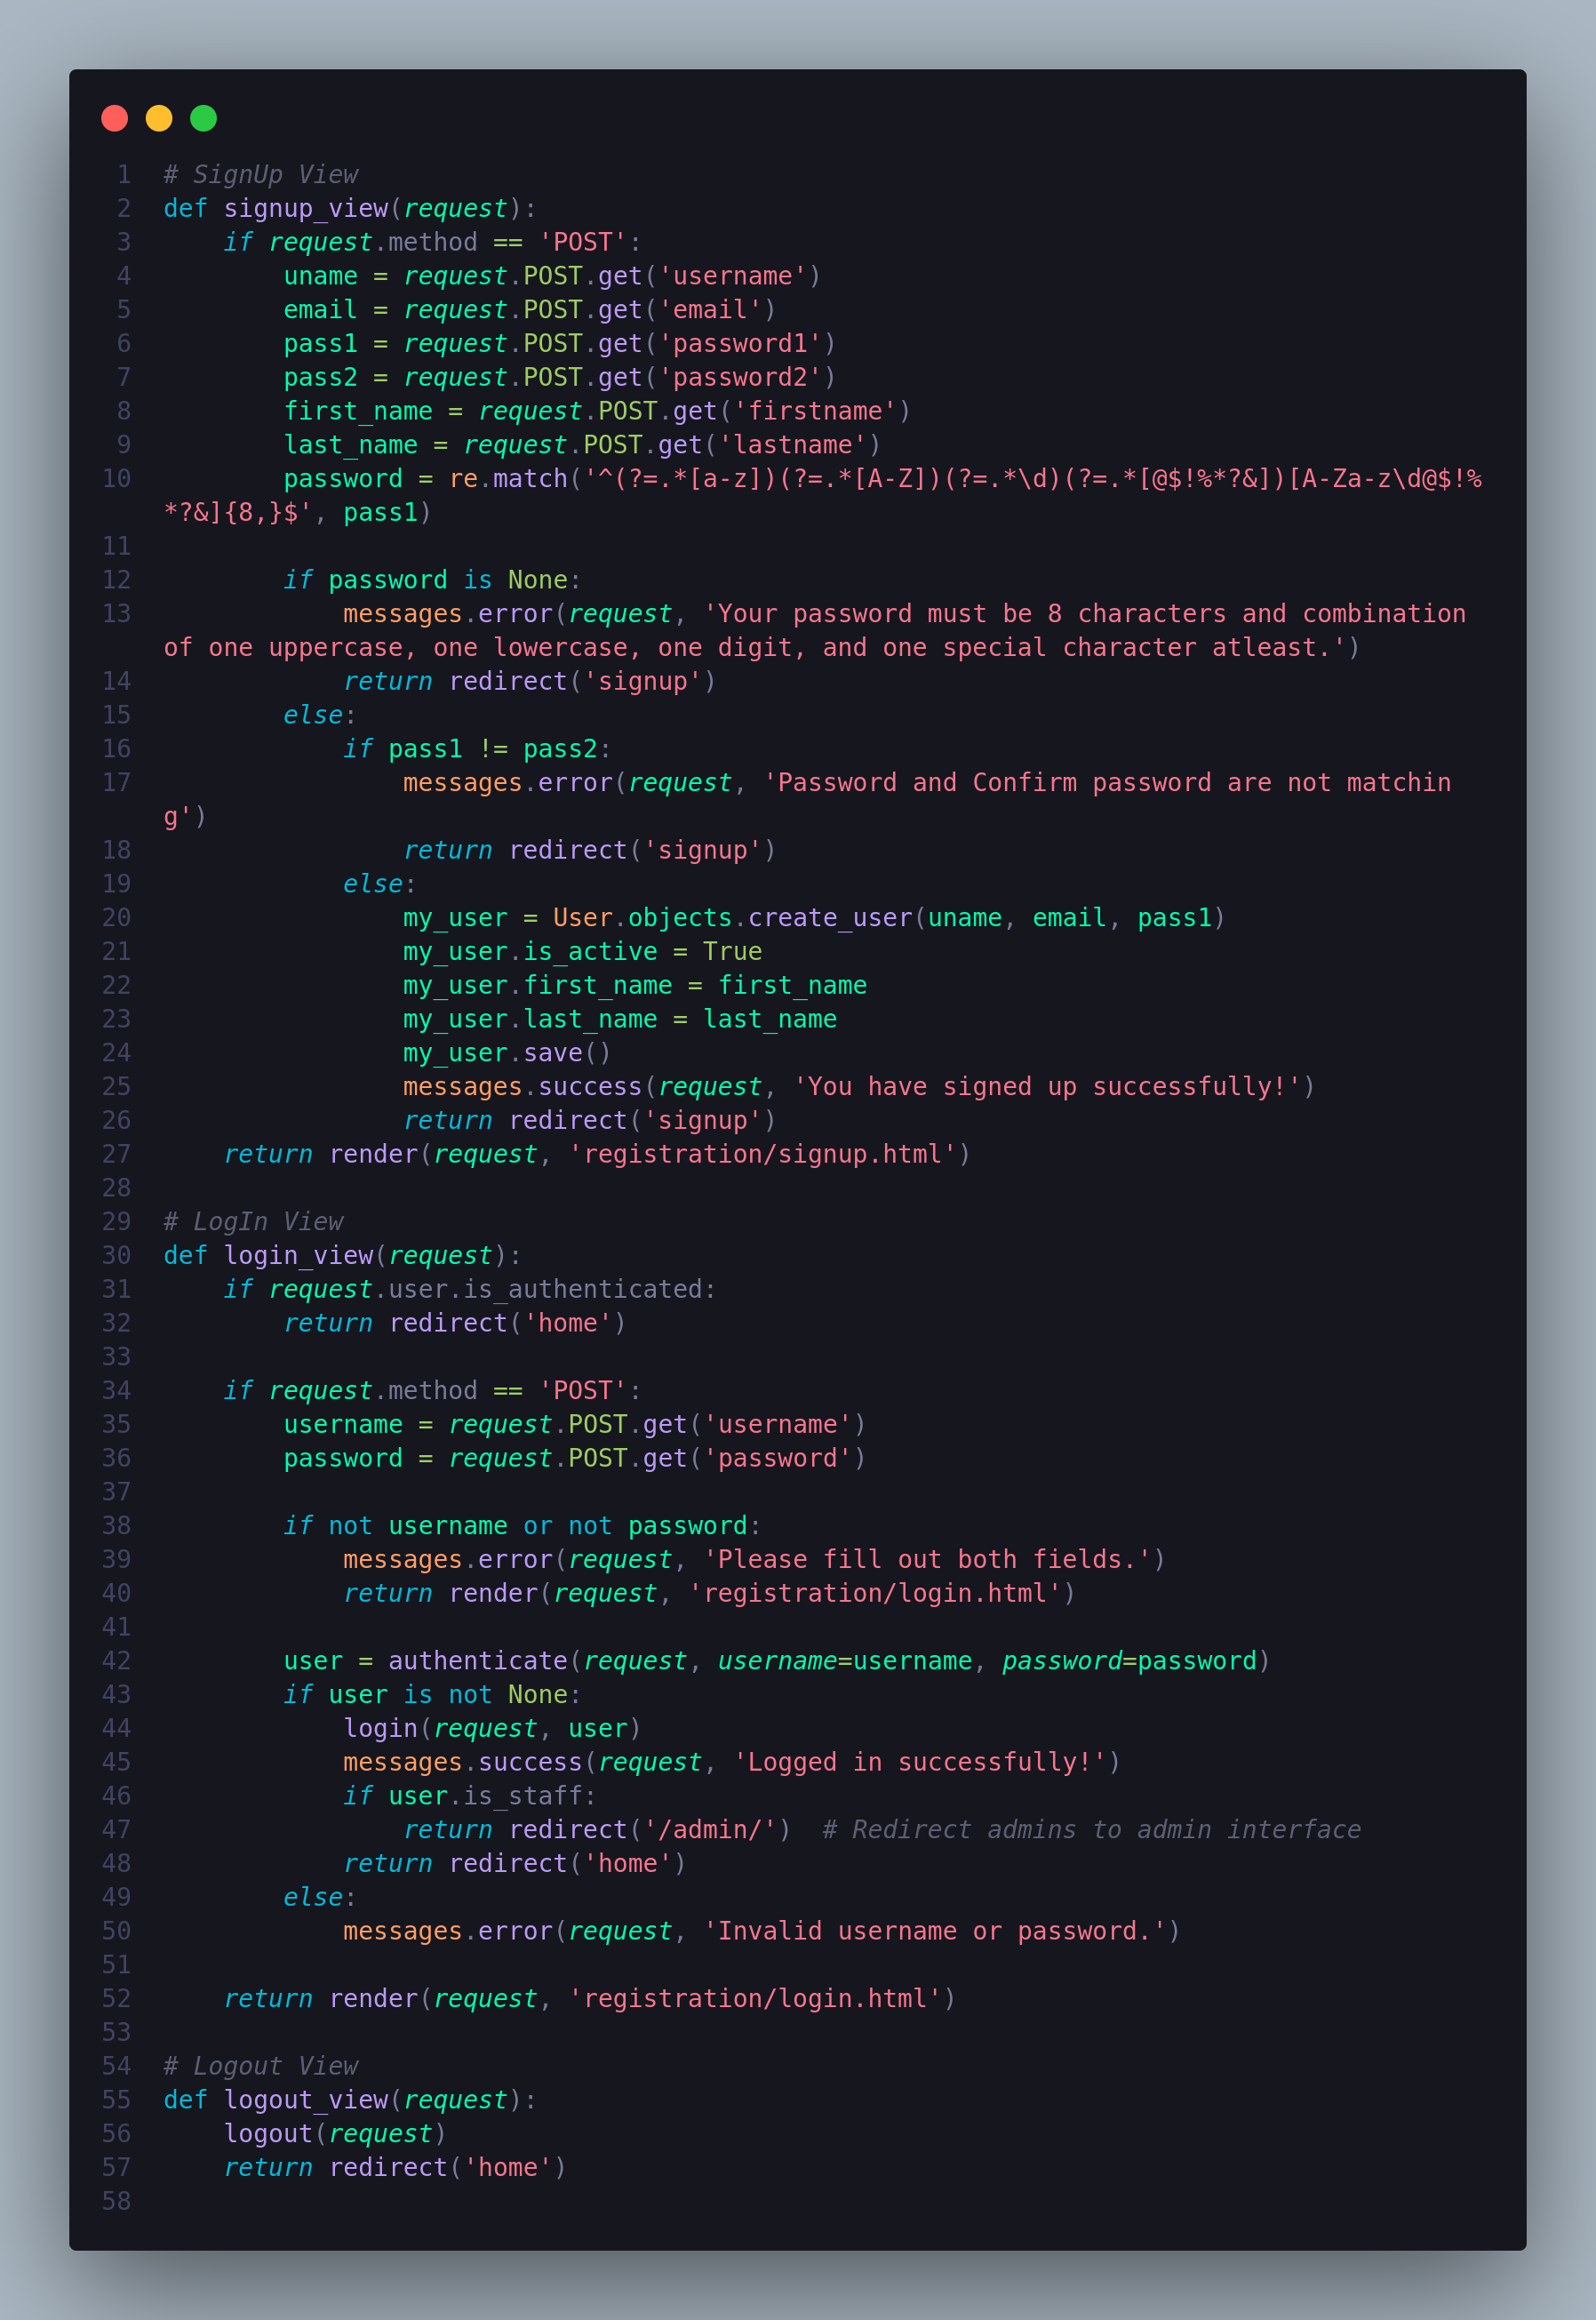

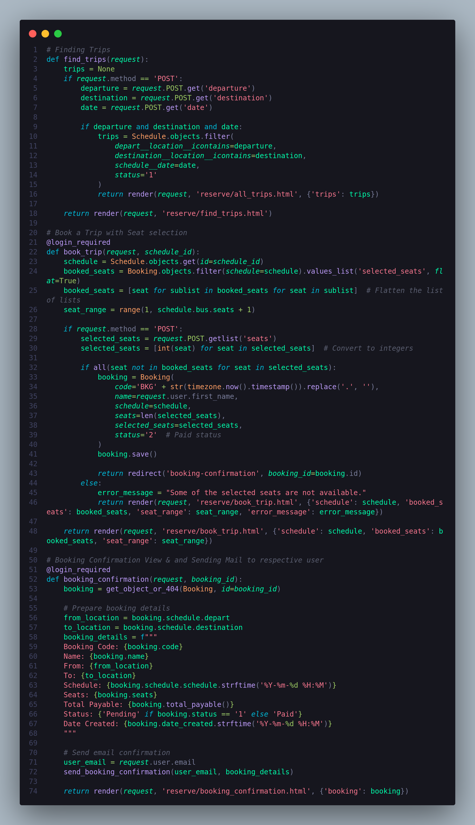

### 

### 

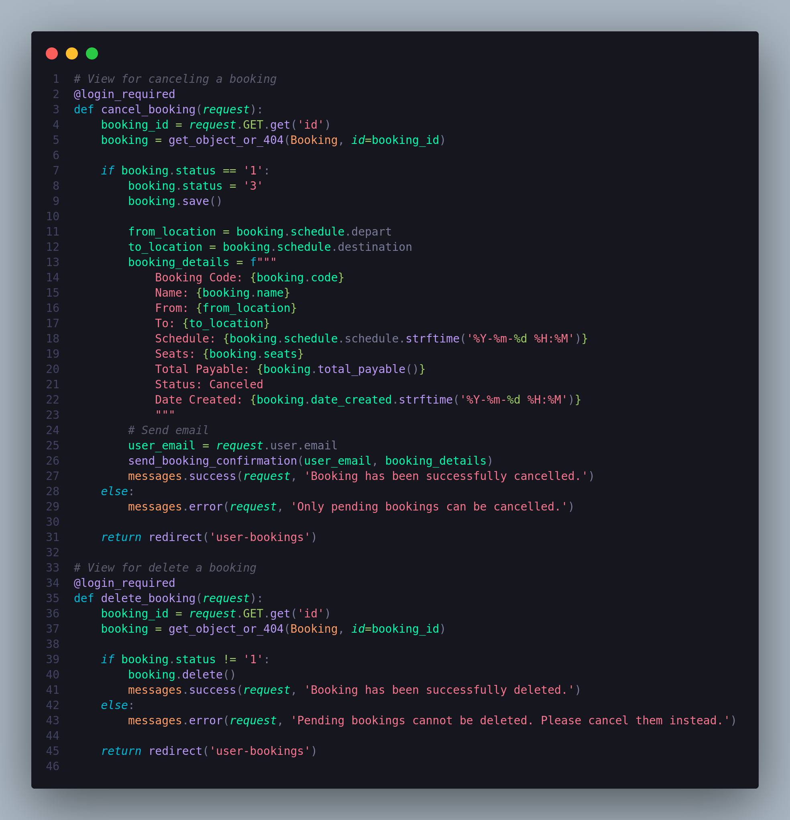

### 3. utils/email_utils.py

The email_utils.py file contains utility functions that are used across different parts of the project. These functions help keep the codebase organized and avoid redundancy. In the Busify project, utility functions include:

* **Email Sending Function**: A function to send booking confirmation emails to users after they book a trip.

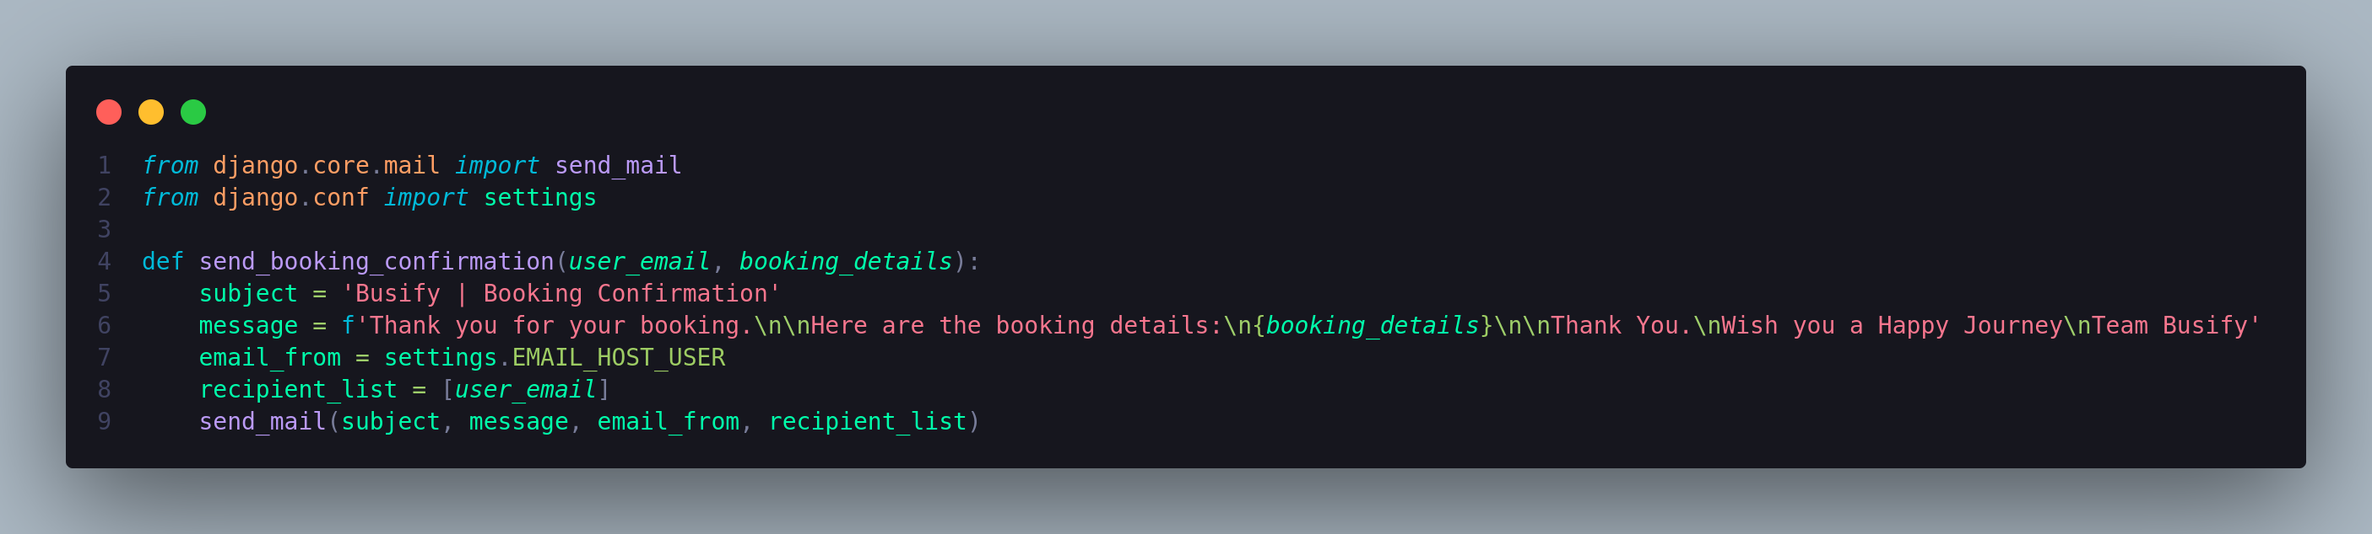4. urls.py

In the Busify project, the urls.py file plays a critical role in defining how users interact with the various pages and functionalities of the application.

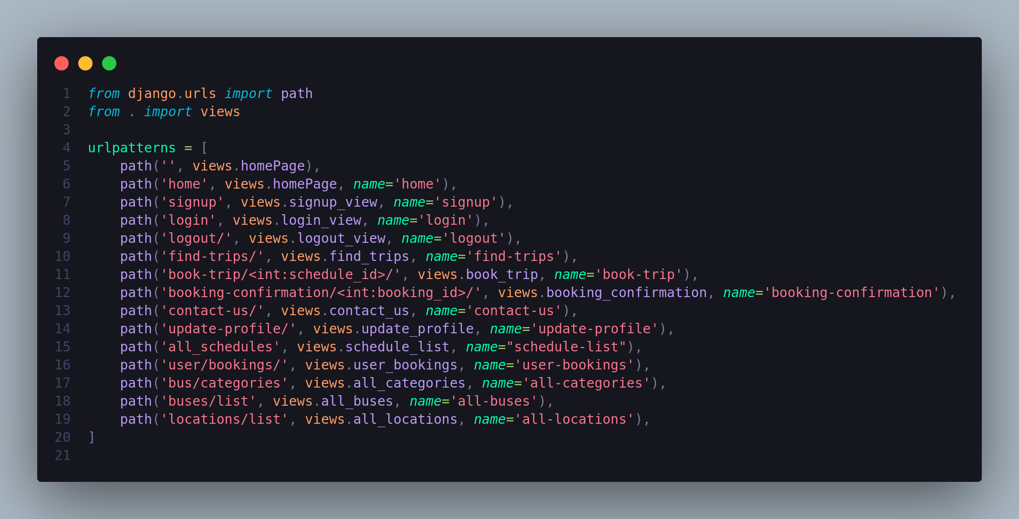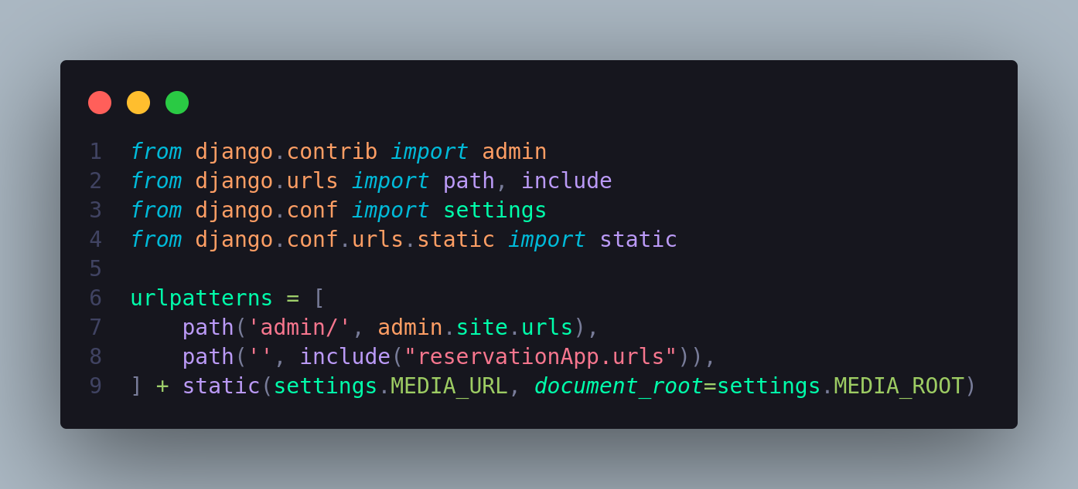

Some Figures from this project :

1. Home Page

Fig.1:-

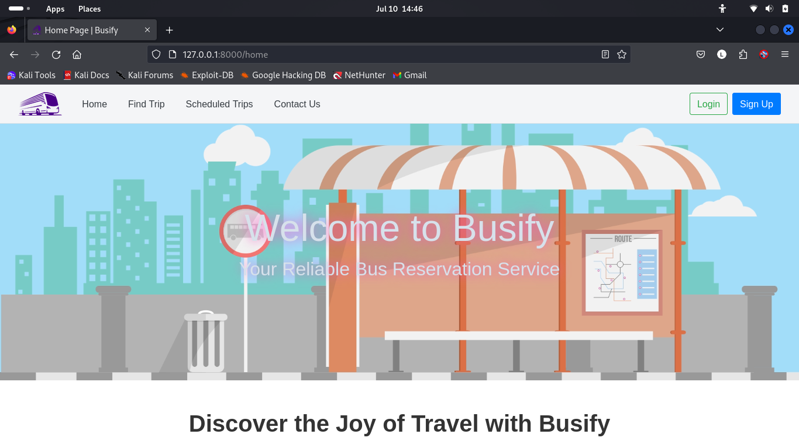

Fig.2:-

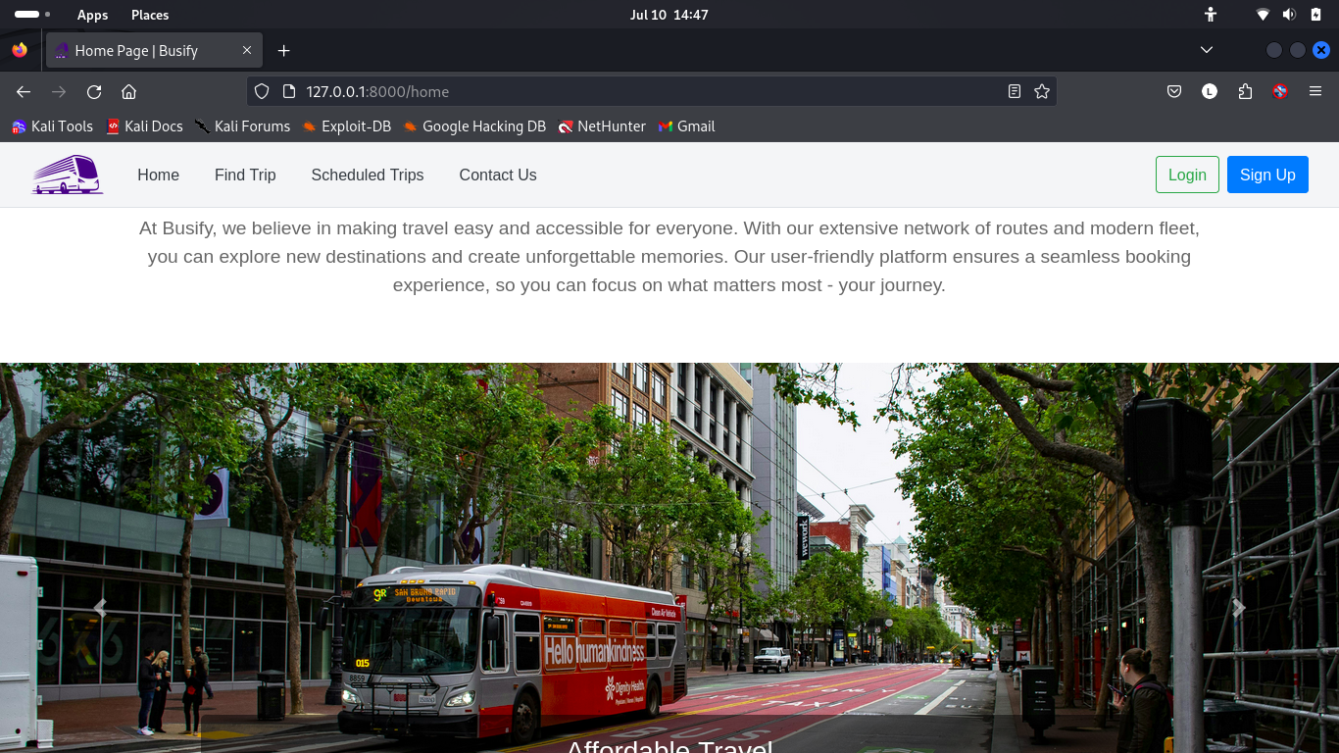Fig.3 :-

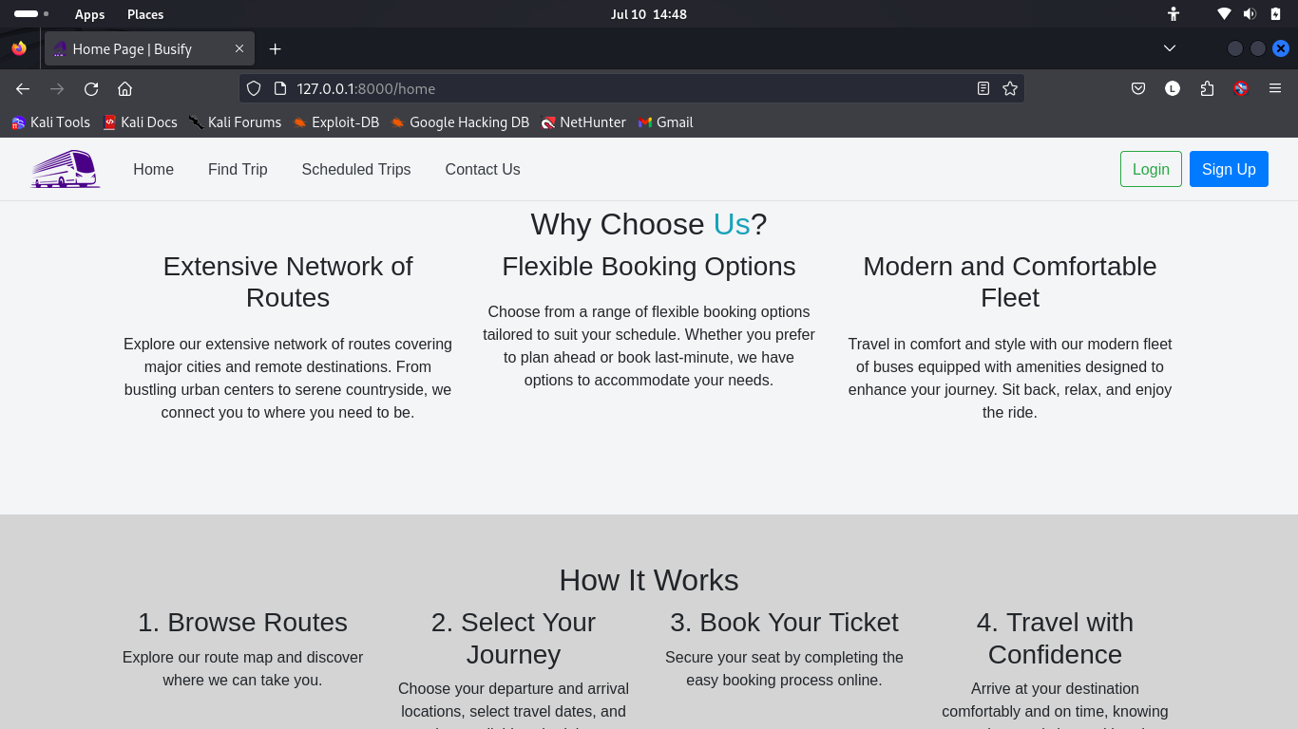Fig.4 :-

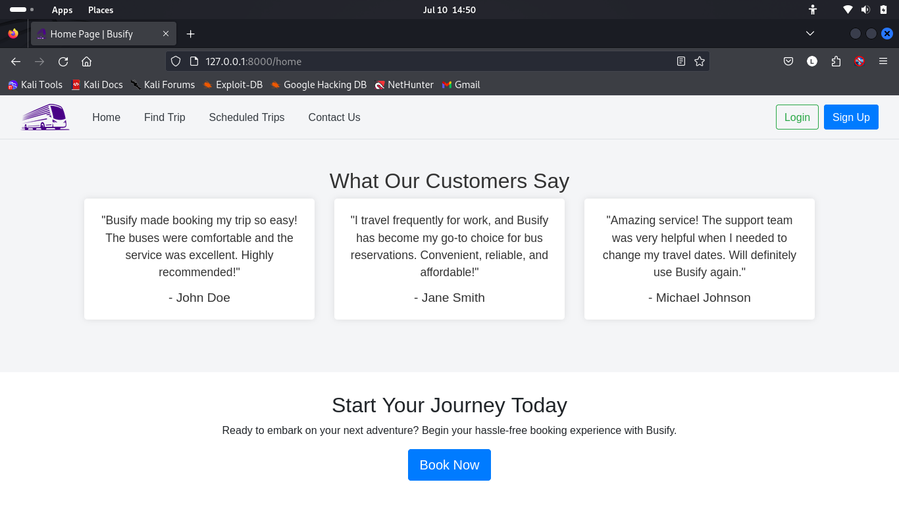

Fig.5 :-

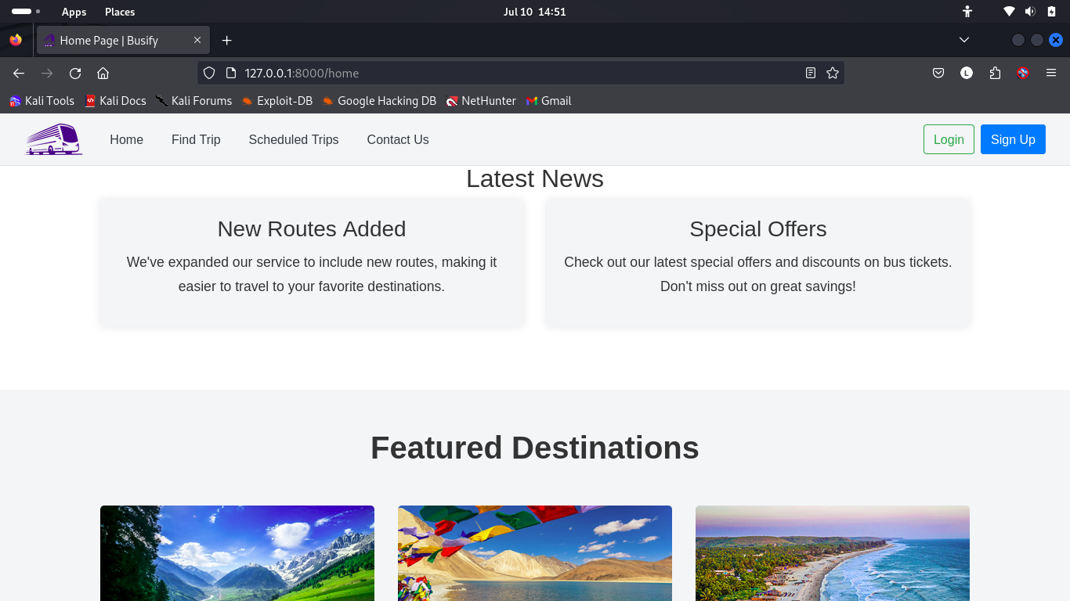Fig.6 :-

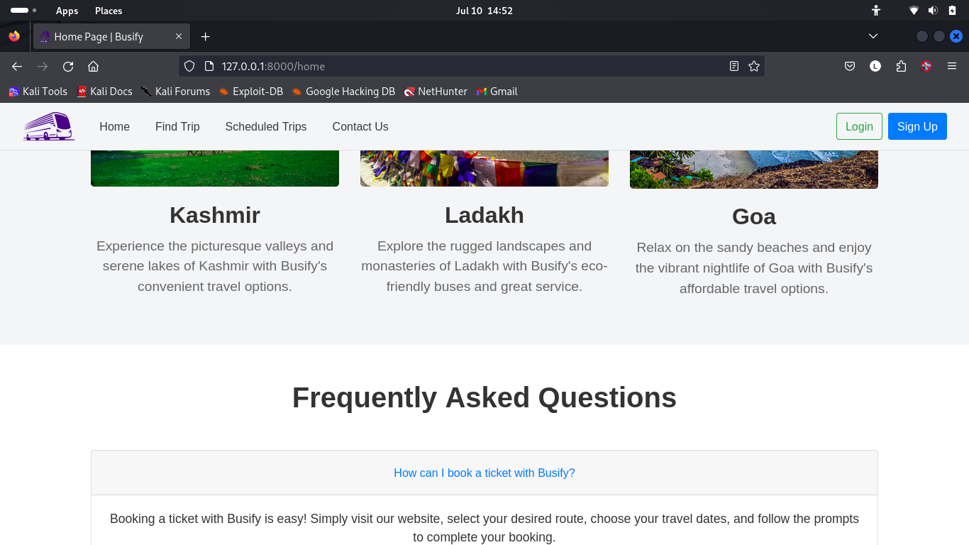Fig.7 :-

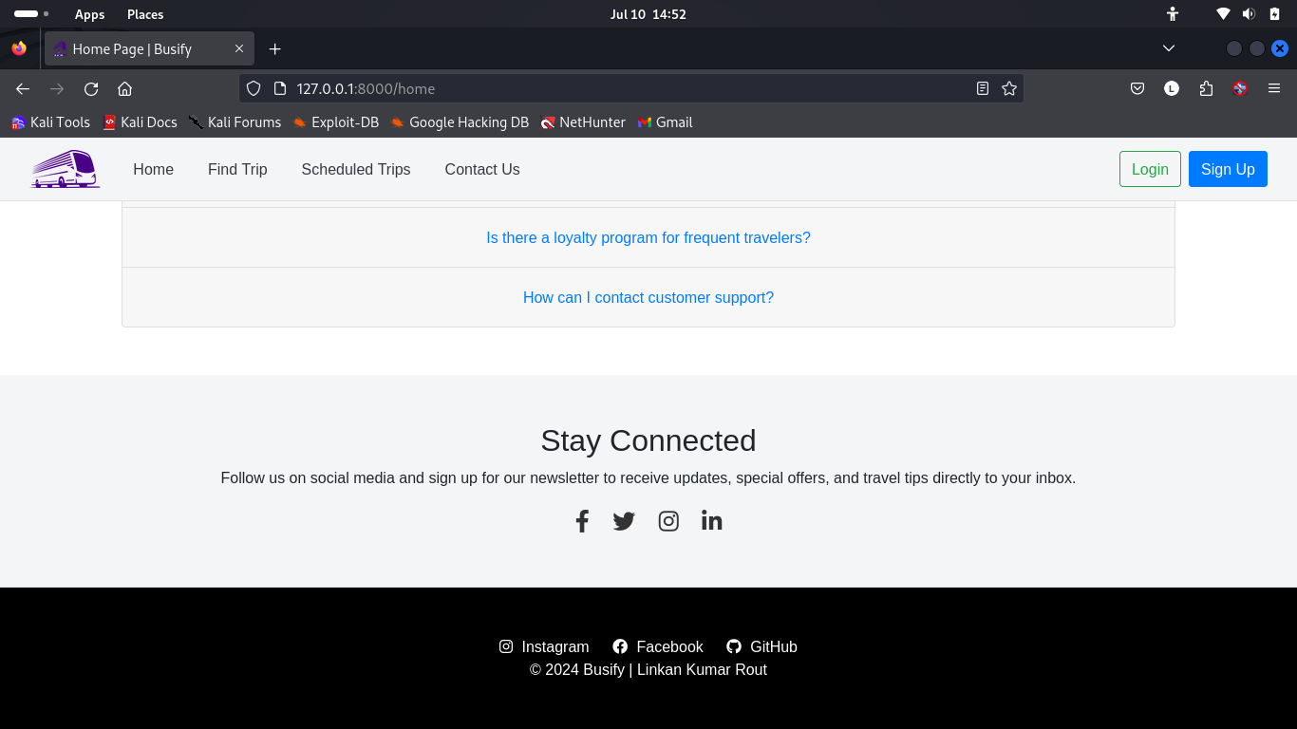2. Log-In Page

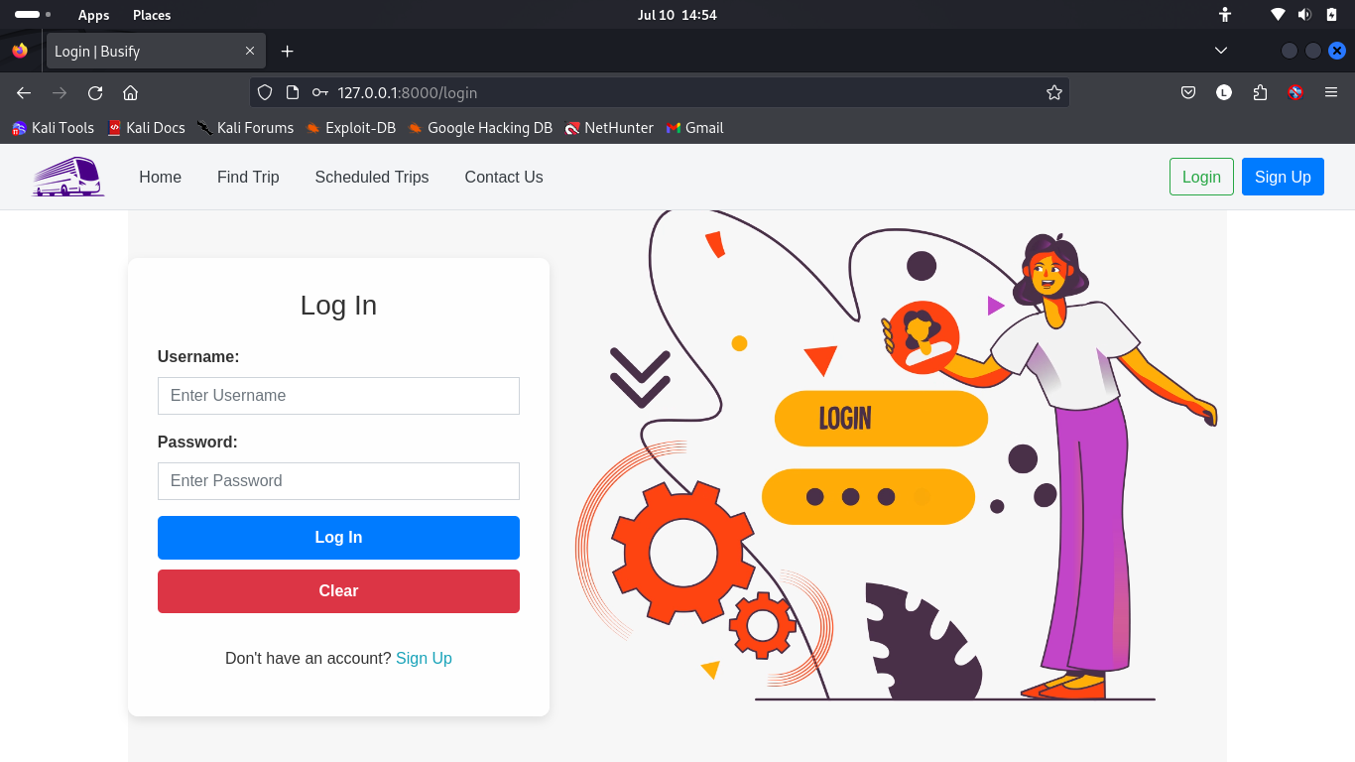

3. Sign-Up Page

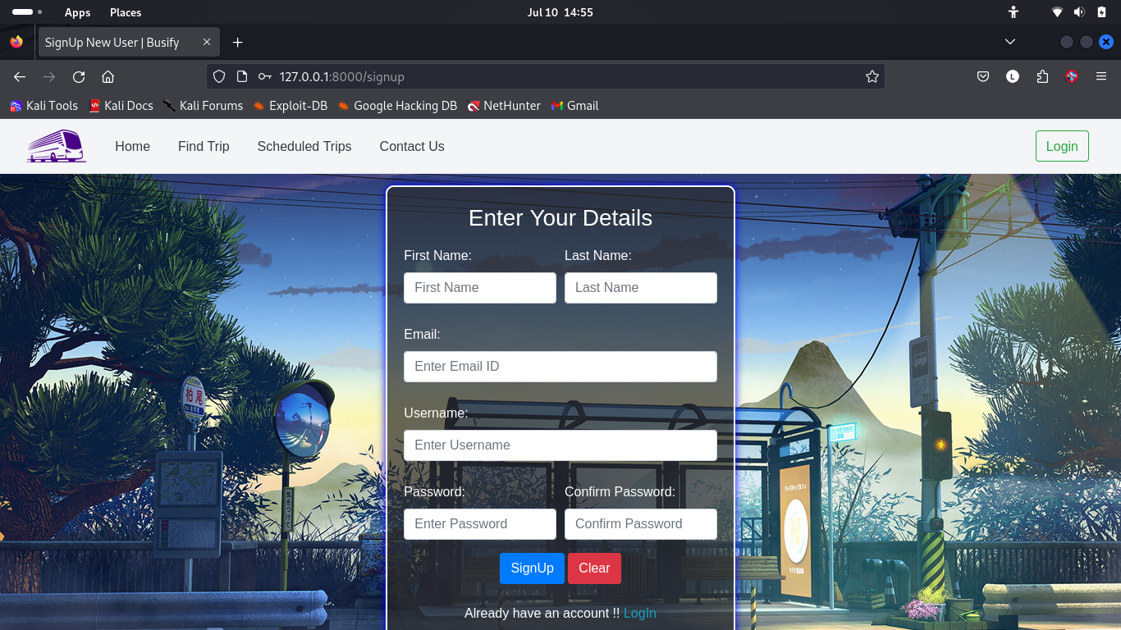

4. User Home Page

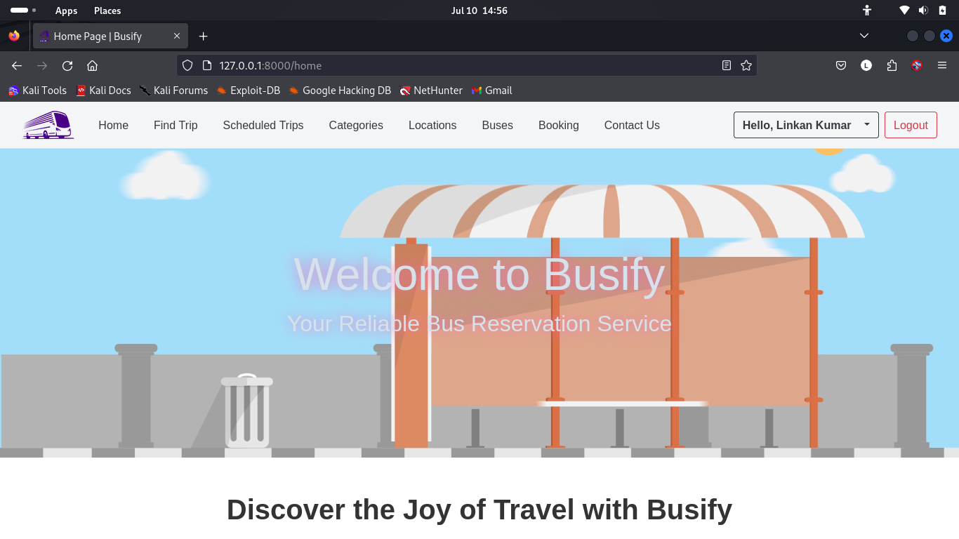

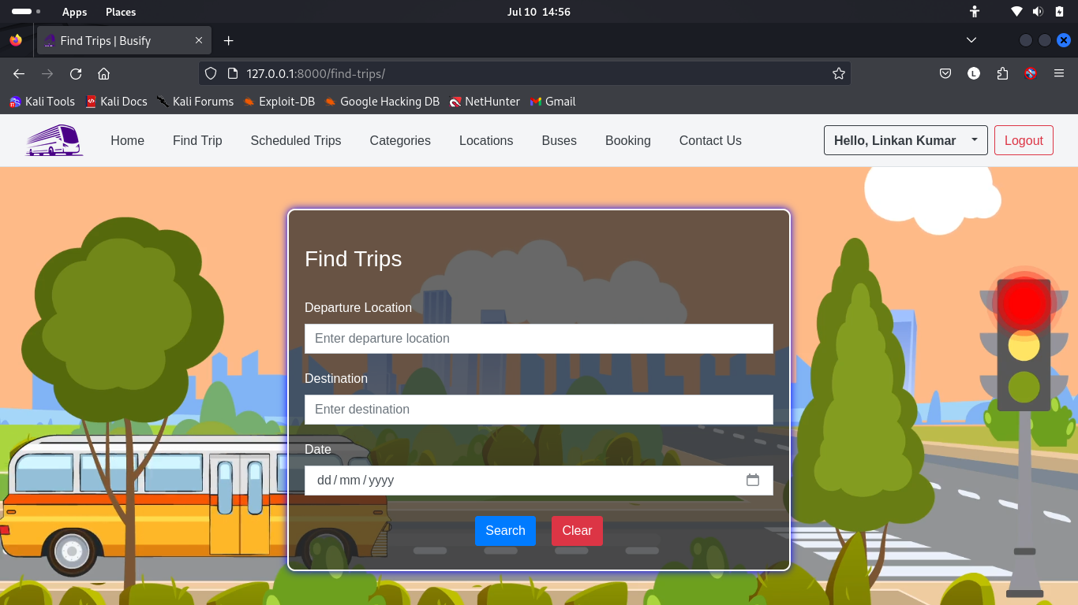5. Find Trips Page

6. Available Trips

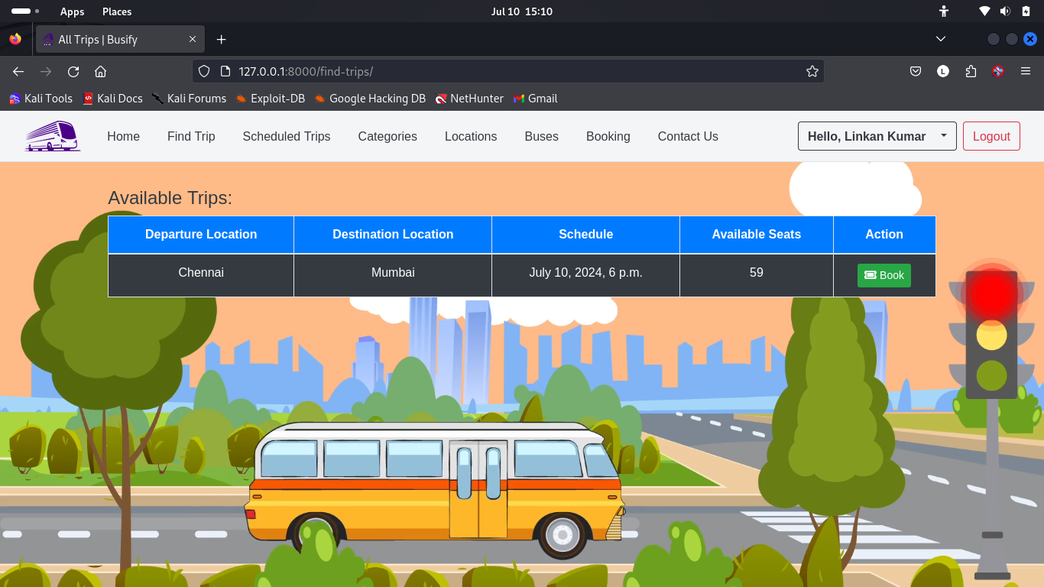

7. Book Trip Page

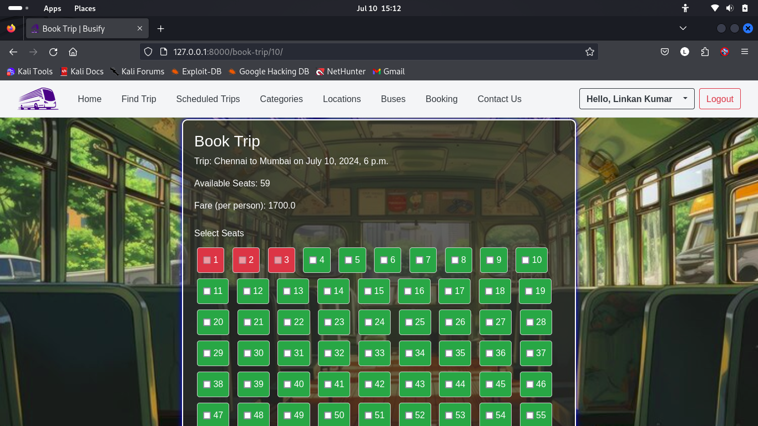

8. User Booking Page

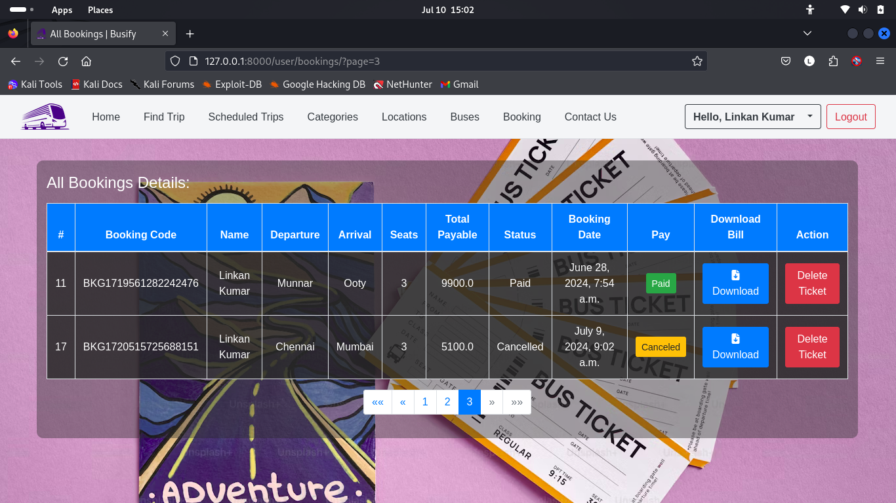

6. Challenges Faced

1. Integrating PayPal's payment gateway presented several validation errors, especially concerning currency format and data consistency. Understanding and implementing the PayPal SDK correctly was initially challenging.

2. Implementing real-time notifications for booking confirmations was essential for user satisfaction but posed challenges in ensuring timely and reliable delivery.

3. Implementing an interactive seat selection system that accurately reflected real-time seat availability was complex, especially with multiple users accessing the system simultaneously.

7. Future Enhancements

**1. Mobile Application Development:**

* **Enhancement:** Develop a native mobile application for both iOS and Android platforms.
* **Benefit:** Enhances user accessibility and convenience, allowing users to book tickets and manage their reservations on the go.

**2. Real-Time GPS Tracking:**

* **Enhancement:** Integrate real-time GPS tracking for buses.
* **Benefit:** Provides users with live updates on bus locations, estimated arrival times, and delays, improving the overall travel experience.

**3. Multi-Language Support:**

* **Enhancement:** Add support for multiple languages.
* **Benefit:** Expands the user base by making the application accessible to non-English speaking users, enhancing usability and user satisfaction.

**4. Loyalty Program:**

* **Enhancement:** Implement a loyalty program to reward frequent travelers with discounts and special offers.
* **Benefit:** Encourages repeat bookings, builds customer loyalty, and increases user engagement.

**5. Advanced Analytics and Reporting:**

* **Enhancement:** Develop advanced analytics and reporting tools for administrators.
* **Benefit:** Provides insights into booking patterns, peak travel times, and revenue trends, aiding in better decision-making and strategic planning.

**6. Integration with Other Travel Services:**

* **Enhancement:** Partner with other travel services like airlines, hotels, and car rentals to offer bundled deals.
* **Benefit:** Provides users with comprehensive travel solutions, enhancing convenience and potentially increasing bookings.

**7. Enhanced Security Measures:**

* **Enhancement:** Implement advanced security measures such as two-factor authentication and enhanced data encryption.
* **Benefit:** Ensures user data security and builds trust, reducing the risk of data breaches and fraud.

**8. AI-Powered Chatbot:**

* **Enhancement:** Introduce an AI-powered chatbot to assist users with booking inquiries and support.
* **Benefit:** Provides instant customer service, improving user satisfaction and reducing the load on customer support teams.

8. Conclusion

In conclusion, the Busify project has successfully established a comprehensive bus reservation system that addresses the needs of modern travelers. Through a user-friendly interface and efficient backend architecture, the system streamlines the booking process, enhances user experience, and ensures secure transactions. Despite challenges faced during development, such as integrating payment gateways and maintaining data security, the project has emerged as a robust solution in the transportation sector. With a clear vision for future enhancements, including mobile application development and real-time GPS tracking, Busify is well-positioned to adapt to evolving user demands and technological advancements, paving the way for continued growth and innovation in the bus reservation landscape.

9. References

* **Django Documentation**: https://docs.djangoproject.com
* **Bootstrap Documentation**: https://getbootstrap.com/docs
* **PayPal Developer Documentation**: https://developer.paypal.com/docs
* **MDN Web Docs**: https://developer.mozilla.org
* **Stack Overflow**: [https://stackoverflow.com](https://stackoverflow.com/)